27th Annual
Glasgow Lands Scottish Festival

Saturday,
July 16, 2022
Rain or Shine
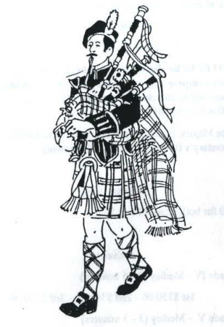

Piping
Competition
Sanctioned by the EUSPBA
Look Park
300 North Main Street

Florence, Massachusetts

Solo Events Scheduled to Start 8:00 AM

Massed Bands at 11:30 AM & 5:30 PM

Pipe Band Competitions to Start 1:00 PM

www.glasgowlands.org

Please enter me in the events listed. I hereby, for myself, my heirs, executor and administrators, waive and release any and all claims I may have for damages against Glasgow Lands Scottish Festival, Inc., their agents or representatives and the owner of the property on which the Games are held, for any injuries which may be suffered by me during the Glasgow Lands Scottish Festival.

Signature (of parent or guardian, if under 18 years of age)

AMATEUR PIPING
Solo Piping Entry Form

All solos to follow EUSPBA rules.
Please circle the events you wish to enter.

GRADE 1
- Piobaireachd
- MSR
- Hornpipe/Jig

GRADE 2
- Piobaireachd
- Strathspey & Reel
- 2/4 March

GRADE 3
- Piobaireachd
- Strathspey & Reel
- 2/4 March

Grade 4 SR
- Piobaireachd
- 2/4 March

GRADE 4 JR
- Piobaireachd:
- 2/4 March

GRADE 5 *
- March
- Ground Piobaireachd

PRACTICE CHANTER *
- 4 Part March

Entry fee is $40.
*Fee for Practice Chanter and Grade 5 is $22.
For questions, contact:
Diane at 413-454-4793
dgp296@charter.net

*INDIVIDUAL EVENT FEES*

Entry Fee ………….…… $ _________

Additional Tickets:
Adults: __________x $22 _________
Children (Age 6-12): _________x $ 5 _________

Total: _________

Name:___________________________________________

Address:_________________________________________

_______________________________________________

City: __________________ State: Zip:_______

DOB (Grade 4 Jr only): ____________________________

Telephone:_______________________________________________
Email:__________________________________________

Grade:________________________________________________________
EUSPBA #: _____________________________________

Events#__________________________________________

Are you competing with a band at event? Yes No

Name of Band: ____________________________

_________________________________________

All entries MUST be postmarked, no later than June 24th!
To receive your ticket, please enclose the required entry fee, entry form, and a Self-Addressed Stamped Envelope and mail to:
Glasgow Lands Scottish Festival, Inc.
c/o Diane Peacey
608 Fuller Street
Ludlow, Ma. 01056

Please make all checks payable to:

GLASGOW LANDS SCOTTISH FESTIVAL, INC.

