Solo Drumming Entry Form

27th Annual
Glasgow Lands Scottish Festival

Saturday,
July 16, 2022
Rain or Shine
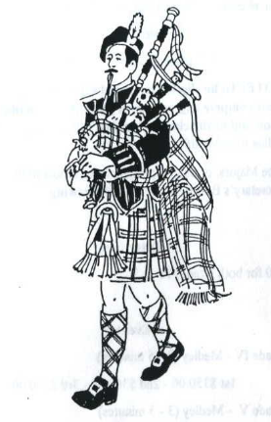
Drumming
Competition

Sanctioned by the EUSPBA

Look Park
300 North Main Street

Florence, Massachusetts

Solo Events Scheduled to Start 8:00 AM

Massed Bands at 11:30 AM & 5:30 PM

Pipe Band Competitions to Start 1:00 PM

www.glasgowlands.org

Please enter me in the events listed. I hereby, for myself, my heirs, executor and administrators, waive and release any and all claims I may have for damages against Glasgow Lands Scottish Festival, Inc., their agents or representatives and the owner of the property on which the Games are held, for any injuries which may be suffered by me during the Glasgow Lands Scottish Festival.

Signature (or of parent or guardian, if under 18 years of age)

All solos to follow EUSPBA rules.

Please circle the events you wish to enter.

SNARE DRUMMING

- Grade 1 MSR
- Grade 1 Hornpipe/Jig
- Grade 2 MSR
- Grade 2 Hornpipe/Jig
- Grade 3 2/4 March
- Grade 3 Strathspey/Reel
- Grade 4 Jr March
- Grade 4 Sr March
- Grade 5 March
- Drum Pad

Entry Fee is $25.00

*INDIVIDUAL EVENT FEES*

Entry Fee………………………… $ $25.00_____

Additional Tickets:
Adults: _________x $ 22 ________
Children (Age 6-12): _________x $ 5 _________

Total: _________

For questions, contact:
Diane at 413-454-4793
dgp296@charter.net

Name:__________________________________________________________

Address:_______________________________________

_____________________________________________________

City: ___________________State: ________ Zip: _______

DOB (if Grade 4 Jr Only) __________________________

Telephone #: _____________________________________

Email:_________________________________________

Grade: ________________________________________

EUSPBA: _______________________________________

Events:___________________________________________________________

Are you competing with a band at event? Yes No

Name of Band: ____________________________

_________________________________________

All entries MUST be postmarked, no later than June 24th!

To receive your ticket, please enclose the required entry fee, entry form, and a Self-Addressed Stamped Envelope and mail to:
Glasgow Lands Scottish Festival, Inc.
c/o Diane Peacey
608 Fuller Street
Ludlow, Ma. 01056

Please make all checks payable to:

GLASGOW LANDS SCOTTISH FESTIVAL, INC.

