27th Annual

Glasgow Lands Scottish Festival

July 16, 2022
Rain or Shine
2022 Pipe Band Competition Entry Form

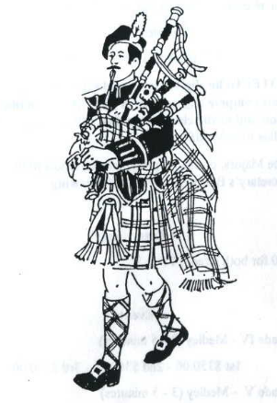
Sanctioned by the EUSPBA
Look Park
300 North Main Street

Florence, Massachusetts

Massed Bands at 11:30 AM & 5:30 PM

Pipe Band Competitions to Start 1:00 PM

All pipe band entries must be postmarked no later than June 24th, 2022. No field entries will be accepted.

A band meeting will be held at 10 a.m. at the registration booth. Please send a representative to be briefed on massed band formation and times.

Glasgow Lands Scottish Festival reserves the right to offer one prize less than the number of bands entered in a grade level. If only a single band registers at a grade level, GLSF reserves the right to reduce the prize money by $100.

BAND EVENTS*

Grade II:
1st $450 - 2nd $400 - 3rd $350

Grade III:
1st $425 - 2nd $375 - 3rd $325

Grade IV:
1st $375 – 2nd $325 – 3rd $275

Grade V:
1st $325 – 2nd $275 – 3rd $225

Requests to play up will be considered after registration closes to determine whether time is available.
Pipe Band Entry Fees: The band fee is $225 and will include tickets for all members playing in the competition. Please note, that if a member of your band has registered for individual competition, a ticket was already provided to them and will not be included in the bands ticket count.
A roster of playing members must accompany the competition entry form.
Checks should be made payable to: Glasgow Lands Scottish Festival.
The entry form must include a self-addressed stamped envelope for tickets to be sent to you. Additional postage (2 stamps) is needed to send tickets. Mail to:

Glasgow Lands Scottish Festival, Inc.
c/o Diane Peacey
608 Fuller Street
Ludlow, Ma. 01056

Band Fee: $ 225.00

Additional Tickets:
Adults: _________x $22.00__
Children (Age 6-12): _________x _$ 5_____

Total: _________

…………………………………..

Band Name: __________________________________________

Band Contact
Name: ____________________________________

Address: ____________________________________

City: ____________________________________

State: __________________ Zip: _______________

Telephone #_________________________________

Email: ____________________________________

EUSPBA #: _________________Grade: _________

Questions?
Call:
Diane at 413-454-4793
dgp296@charter.net

