27th Annual
Glasgow Lands Scottish Festival
Drum Major Individual Entry Form

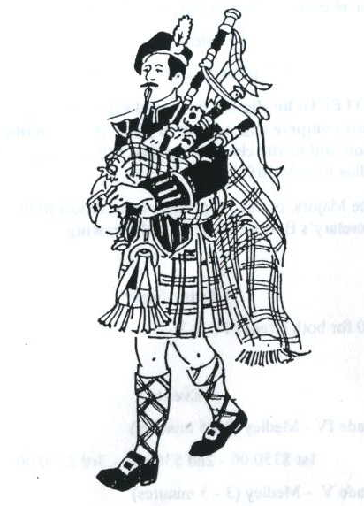

Drum Major Competition
Sanctioned by EUSPBA

Saturday July 16, 2022
Rain or Shine
Look Park
300 North Main Street

Florence, Massachusetts

Solo Events Scheduled to Start 8:00 AM

Massed Bands at 11:30 AM & 5:30 PM

Pipe Band Competitions to Start 1:00 PM

Drum Major Competition after Opening Ceremonies – approximately 12:15

www.glasgowlands.org

The location of the contest will be announced after 8am at Registration. A duty band will be provided by the Festival.

The prizes will be as follows:

Amateur: Medals
Professional: $100 first place
$75 second place
$50 third place

ENTRY FEES:
Professional $25.00
Amateur $22.00
(Circle which applies)

Additional Tickets:

Adults: _________ x $22 ________
Children (Age 6-12): ________ x $ 5 ________

Total: _____________

QUESTIONS?
Contact:
Diane at 413-454-4793
dgp296@charter.net

Please enter me in the events listed. I hereby, for myself, my heirs, executor and administrators, waive and release any and all claims I may have for damages against Glasgow Lands Scottish Festival, Inc., their agents or representatives and the owner of the property on which the Games are held, for any injuries which may be suffered by me during the Glasgow Lands Scottish Festival.

Signature (of parent or guardian, if under 18 years of age)

Name: ____________________________________

Address: ____________________________________

___________________________________________

City: ____________________________________

State: _________________ Zip:___________

Telephone #_________________________________

Email: ____________________________________

Grade (Professional vs. Amateur): _______________

EUSPBA #: ________________________________

Event: _____Drum Major Competition_______

Are you competing with a band at event? Yes No

Name of Band: ____________________________

_________________________________________

All entries MUST be postmarked, no later than June 24th!
To receive your ticket, please enclose the required entry fee, entry form, and a Self-Addressed Stamped Envelope and mail to:
Glasgow Lands Scottish Festival, Inc.
c/o Diane Peacey
608 Fuller Street
Ludlow, Ma. 01056

Please make all checks payable to:

GLASGOW LANDS SCOTTISH FESTIVAL, INC.

