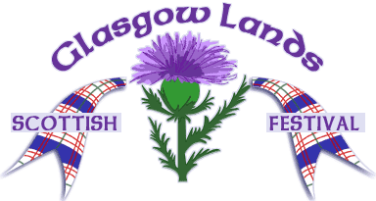 | Glasgow Lands Scottish Festival

25th Anniversary Benefit Concert Ticket Order Form

Date: Sunday, May 6, 2018
Times: 2:00 PM to 5:00 PM
Location: The White Church
4 North Street
Blandford, MA 01008
Featuring: Charlie Zahm, vocal & guitar; Zoë Darrow, fiddle; John McIntyre, bagpipes

Contact Information
Name:
 | First | Last
Address:
 | Street Address |  | Apartment/Unit #
 | City | State | ZIP Code
E-Mail:

Ticket Information
Please send Concert tickets @ $15.00 each
Please send For children under 16 @ $5.00 each
Check for enclosed with a self-addressed stamped envelope

Please fill out the order form, print, then send to address below.
(Deadline for Tickets by Mail is April 25th)
Check should be made payable to Glasgow Lands Scottish Festival, Inc. and mailed to:
Concert Tickets
PO Box 86
Blandford, MA 01008

All proceeds to benefit the White Church preservation fund and the Glasgow Lands Scottish Festival, Inc.
Glasgow Lands and The White Church are 501(c)3 non-profit organizations.
© 03/10/2018 Glasgow Lands Scottish Festival

